**Lab Task 1 circuit Diagram:**

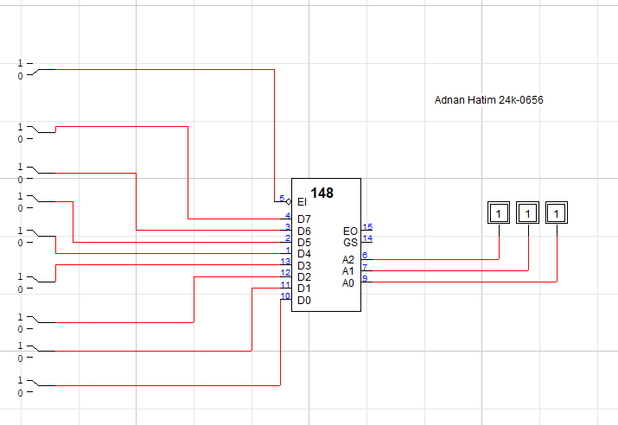

**Lab Task 2 circuit Diagram:**

